

Sous Chef Reference Manual
S27

Welcome to CMH! Due to the uniqueness of our vast operation, please consider this manual your training guide to service standards, expectations, and job descriptions.
The fact that you have been chosen to join this distinct group of adventure tourism professionals means that you play an integral role in the creation of one of the finest backcountry experiences in the world. It is our goal to ensure that CMH is known not only for its Heli-skiing and Heli-hiking but also for its hospitality program, which you are now a part of.
We are expecting you to bring your personality, creativity, knowledge, and professionalism with you to work every day to ensure that every guest has an exceptional experience.
It is important to us at CMH that you are given the tools and support you need to succeed in this business. We are not only committed to creating memories for our external guests, but for you, our internal guests as well.
We want our team to feel motivated, inspired, and healthy so that we can maintain a level of excellence that is unparalleled in our industry. If at any time you feel as though you are lacking information or skills that you need to better your performance, please take the time to communicate and we will do our best to fulfill your request.
We are excited to have you join the CMH family, a company that is devoted to creating unforgettable experiences for every single guest, every single time.

Your team:
Randy Luft - CMH Culinary Manager rluft@cmhheli.com
Sarah Palmer – Culinary Purchasing Manager SPalmer@cmhheli.com
Alan Fraser – Director of Hospitality afraser@cmhheli.com

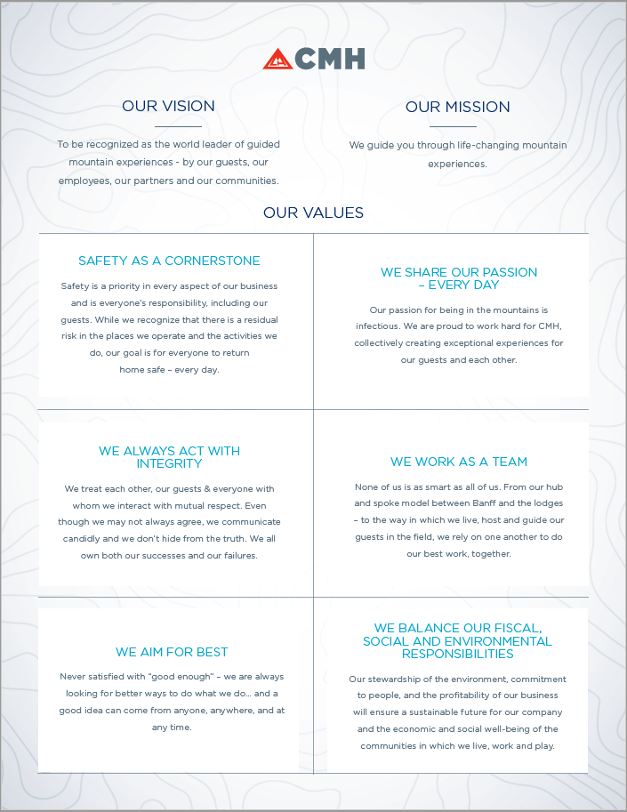
Contents
INTRODUCTION 4
SOUS CHEF BASIC DAILY TIME LINE 4
EXCHANGE DAY 5
APRES SKI 5
MENU PLANNING 6
DIETARY NEEDS 6
DEALING WITH LAST MINUTE GUEST REQUESTS 6
OTHER DUTIES 6
OTHER DUTIES ………………………………………………………………………………………………………………………………… 6

INTRODUCTION
With ever increasing responsibilities and the desire to improve the quality of the program and the diversity of the offerings we can provide; the Sous chef role has been created as a “support role” for the other positions in the kitchen. Please consult chef, pastry chef and first cook manuals to help inform yourself of any duties or tasks that may be required to assist them. It is the intention that the Sous chef use their skills both to assist completing any responsibilities that require extra assistance as well as helping to elevate the culinary program by adding their own experience and talents to the team. In addition, they may be asked to “fill-in” in a position if the person normally in the role is unable to fulfill their duties. This is a very dynamic role, and the daily timeline will vary. Remember your compensation reflects an 11-hour workday. It is your responsibility to manage your time efficiently and collaborate effectively.

SOUS CHEF BASIC DAILY TIME LINE
 | Time | Duty
Morning | 6:30-7:30am | Assist first cook to assemble and pack field lunches
 | 7:30am | Assist Chef with Breakfast if needed
 | 8am | Breakfast Service
 | 8:30am | Staff Breakfast (have fresh product for staff)
Prep | 9.00 | Menu and prep plan with culinary team
 | 9:30 | Prep for après and if needed help chef and pastry chef prep
 | 11:00 | Break
 | 12:30pm | Lodge Lunch (Staff & Guests that have come in early from the field)
Après | 3:00pm | Start après, make smoothie
 | 4-4:30pm | Tea goodie service depending on arrival of guests (stay in communication with Bartender on Duty)
Dinner | 6:00pm | Assist Chef with Appetizer
 | 7:00pm | Assist Chef with Main Course
 | 7:45 | Assist Pastry Chef with Dessert
 | 8:00 | Eat Dinner
 | 8:30 – 9pm | Kitchen clean up, consult with First Cook about lunches, Après prep

EXCHANGE DAY
Whether you are leaving, arriving, or bridging tours today is an exceptionally hectic day. While every lodge has different exchange times, there will still be breakfast, lunch and dinner and the incoming and outgoing staff must work together to ensure that all meals go smoothly. Breakfast on exchange day will be business as usual but may be 15 minutes earlier. Lunch is usually served as a buffet, either to outgoing or incoming guests depending on the guest exchange time. Dinner will be prepped and planned by the chef and pastry chef as usual, but there will be a handoff in the case of a staff exchange. On exchange day expect to help the chef with whatever they may need for meals, such as breakfast sandwiches for the staff or perhaps help put together the lunch buffet for the guests. You will be expected to help organize and clean the storage rooms, fridges, and freezers to get ready for food order. Lastly you will be expected to help with dishes, pots, and pans.

APRES SKI (TEA GOODIE)
You will be responsible for the Après Ski Snack. Each afternoon when the guests arrive back from their activities, we provide a “Apres Ski” snack for them. Always serve a choice of at least two or three items with one of them being vegetarian/Vegan (refer to dietary sheet for any allergies). Like every other meal standard at CMH, the tea goodie must provide variety and quality.
For example:
- Nachos and chili w/ salsa, sour cream, and guacamole
- Ribs or Wings (chicken and cauliflower) with a veggie/fruit platter and coleslaw
- Three or four types of pizza (gluten free options)
- Make your own tacos (pulled pork, jackfruit, bean) with Mexican rice.
- Cheese & meat board w/ tapas and a section of crackers and bread
- Cold and hot dip selection – hummus, red pepper, hot artichoke cheese dip with pita triangles
- Pulled pork sliders.
- Grilled vegetable salad
- Lettuce wraps, salad rolls
- A veggie or fruit plate and a smoothie of your choice is also included daily.

Salads, platters, and sauces should be in their necessary dishes and any hot dishes in proper pots or serving trays and ready to be served by 4 - 4:30 pm depending on the time of the year or circumstance.
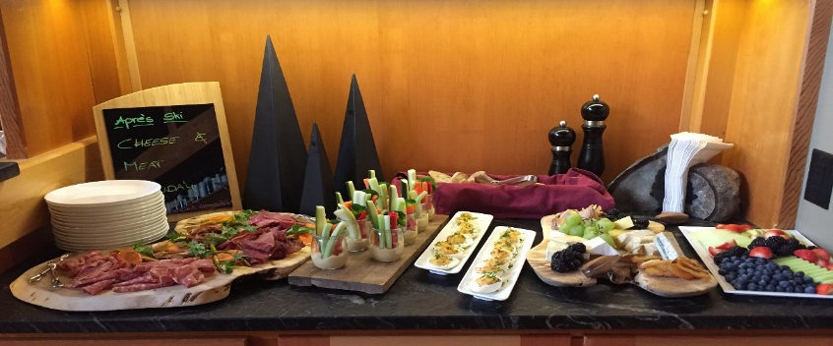
Keep an eye on the buffet for replenishing as guests arrive. You will have the help of the house assistant or bartender but sometimes they get busy with serving drinks. Have backup if needed, some weeks guests eat more than other weeks and some days they are just hungrier. You should always have more than enough. Après Ski ends at 6pm to start to get ready for dinner.
The bartender is there to serve only. Feel free to get creative and plan a ‘theme night’ with the bartender.
*It is the responsibility of the culinary team to ensure that the quality of the food being served is not deteriorating in their absence and that the bartender understands what is to be done to ensure the quality.

MENU PLANNING
The weekly menu will be created with input from all members of the culinary team. Please see the CMH Culinary Manual for details on the process and standards.

DIETARY NEEDS
You will have the master copy in the kitchen tablet as well as a report for each tour from your Lodge Manager. Some guests are vegetarian, and some have religious beliefs or have food preference & allergies. You should accommodate these requests to the best of your ability. Make sure you talk to the guest "in person" and find out exactly his/her dietary needs are.
Make a general announcement at dinner on the first night, inviting guests to let the kitchen know if they have any specific food requirements.
Please forward any special food requests that are not on the printed list to the Lodge Manager so that they can update the guest profile before they leave the lodge.

DEALING WITH LAST MINUTE GUEST REQUESTS
Sometimes you will have little notice that you will need to provide an alternate meal. If you ensure that you always have a selection of thawed meat in the fridge, you will always be prepared.

OTHER DUTIES
The Sous Chef will be asked by the chef and possibly the other members of the culinary team to help them perform or finish there duties so that everything is organized and on time.
For the Chef:
- Specialty meals such as vegetarian, vegan, or special diet requests
- Minor dinner or breakfast prep
- Helping to plate at the time of service
For the Pastry Chef.
- Some minor prep that may be needed
- Helping to plate at the time of service
For the First Cook.
- Helping to organize and pack the field guest lunch.
- Guidance for the staff lunch
- Possible prep to help complete tasks.

OVERVIEW
The Sous chef is a support role as mentioned earlier. You will be involved in all the aspects and roles in the kitchen, so it is important that you familiarize your self with each role and there responsibilities so that you are at least somewhat prepared for what is asked of you.
This role is also considered a succession role, this means that a sous chef that is performing at a high level may have an opportunity to fill in for a chef or a pastry chef depending on your strengths if that person becomes ill or is unable to perform their duties for a period. This will help make the lodge operations run smoothly until we can get you some help for that missing role. This also can be an opportunity to show your skill and knowledge so that in the future if you are interested in a higher responsibility role such as chef or pasty chef you can be possible considered for the role. We would rather promote from within the company if possible.

