

CMH Culinary Handbook
S27

Welcome to CMH! Due to the uniqueness of our vast operation, please consider this manual your training guide to service standards, expectations, and job descriptions.
The fact that you have been chosen to join this distinct group of adventure tourism professionals means that you play an integral role in the creation of one of the finest backcountry experiences in the world. It is our goal to ensure that CMH is known not only for its Heli-skiing and Heli-hiking but also for its hospitality program, which you are now a part of.
We are expecting you to bring your personality, creativity, knowledge, and professionalism with you to work every day to ensure that every guest has an exceptional experience.
It is important to us at CMH that you are given the tools and support you need to succeed in this business. We are not only committed to creating memories for our external guests, but for you, our internal guests as well.
We want our team to feel motivated, inspired, and healthy so that we can maintain a level of excellence that is unparalleled in our industry. If at any time you feel as though you are lacking information or skills that you need to better your performance, please take the time to communicate and we will do our best to fulfill your request.
We are excited to have you join the CMH family, a company that is devoted to creating unforgettable experiences for every single guest, every single time.

Your team:
Randy Luft - CMH Culinary Manager rluft@cmhheli.com
Sarah Palmer – Culinary Purchasing Manager SPalmer@cmhheli.com
Alan Fraser – Director of Hospitality afraser@cmhheli.com

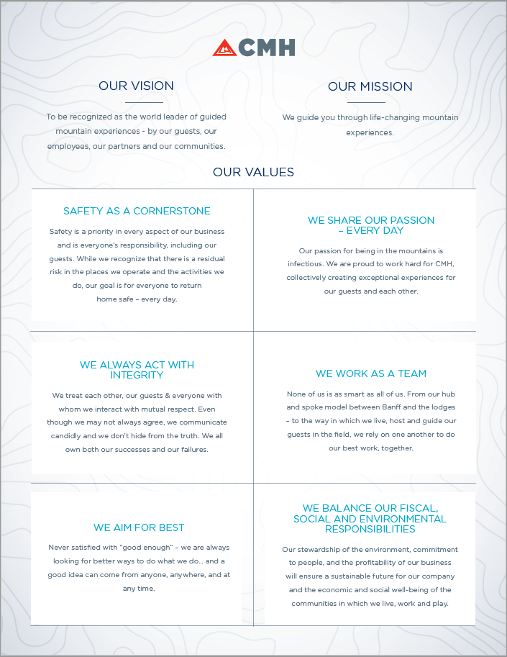
Contents
WELCOME TO THE CMH CULINARY TEAM 5
CMH Culinary Mission 5
Getting started 5
What you need to bring with you 5
Personal Hygiene and Dress Code 5
Lodge Set up 6
INVENTORY AND ORDERING 7
Year at a Glance 7
Pre-season Ordering 7
Weekly Orders & Add-ons 7
Food waste 8
Depleting stock 8
CULINARY EXPECTATIONS 9
Culinary Staff Weekly Meeting 9
Menu Planning 9
Menu Variety and Balance 9
Combination of Flavors 10
Nutritional Principles 10
Food Sensitivities 10
Logistics of Service 10
Presentation 10
MEAL STANDARDS 11
Breakfast 11
Exchange Day Lunch Buffet 11
Field Lunch 12
Lodge Lunch 12
Lunch In 12
Après 13
Dinner 13
Dinner Service Meeting 13
Dinner Service 14
COMMUNICATION AND TEAMWORK 15
Culinary Team 15
Lodge Staff 15
Bartenders 15
Staff & Guest food preferences 15
Lodge and Guides teams 16
Ski program 16
Appendix A : Health Inspections 16
Food Safety Plan Components 16
CMH requirements 17
Appendix B : Logistics of the CMH Culinary program 17
Food transportation and Receiving 17
Receiving food and supplies 17
Truck schedule 18
Heli – need to know list 19
Suppliers 19

WELCOME TO THE CMH CULINARY TEAM

CMH Culinary Mission
To guide people through life changing mountain experiences
- Everyone here has come to enjoy the mountains.
- How we interact with one another is how it becomes life changing
- Every interaction with guests and staff is done with integrity and kindness.
- We are authentic.
- All tasks are done to the best of our abilities.
- We are always aiming for best.
- Our understanding of CMH guidelines and values shows in everything we do.
- We create moments for people that are unforgettable.
Your primary role is to provide an exceptional culinary experience for all CMH guests and staff.
The expectation of our culinary team is that you perform your duties with efficiency and attention to detail. All members of the culinary team will work closely with their Lodge Manager to understand the expectations and details of their positions, including the timelines that each task must be completed in.

Getting started
Each lodge employs a culinary team that includes a Chef, Pasty Chef, Sous Chef and First Cook. As part of the culinary team, your compensation reflects an 11-hour workday. It is your responsibility to manage your time efficiently and collaborate effectively. Developing a kitchen plan with the team at the start of the season will ensure all duties are understood and the workload is manageable for all.
Be mindful that the space is small, and the season is long, so it is imperative to foster an environment of open communication and respect for different working styles and personalities.
Keep in mind our guests are paying a premium price to join us for their holiday, and we want to be proud of every dish or meal we send out to them. You will be expected to perform your responsibilities with efficiency and attention to detail.

What do you need to bring with you
Presenting yourself in a professional manner while cooking is a CMH expectation. CMH Chef Jackets will be supplied at all lodges. Pants are your responsibility, and we suggest bringing two or three pairs of chef’s pants with you. You will also need a pair of WCB compliant closed-toed kitchen shoes.
Each lodge has basic tools, but we suggest you bring your chef’s tools such as knives. Keep in mind that if you are taking a helicopter up to the lodge you must be mindful of the weight of your bags.

Personal Hygiene and Dress Code
Cleanliness and neatness should also be everyone's goal in their personal appearance in performing their cleaning or cooking duties as well as during your free time, including mealtimes. Your accommodation is to be kept neat and clean. Clean hands with short, well-manicured fingernails and well-groomed hair is a responsibility you have towards the guests and co-workers. Long hair is tied up while in the kitchen. Clothing can be casual but not ratty, ripped, or offensive to the guests or co-workers, however Chefs jackets and aprons are mandatory during all meal services. Close-toed shoes must be worn in the kitchen. Be aware of your own safety, loose clothing can catch on things and on fire.

Lodge Set up.
Each lodge will have its schedules set up for all team members to cover job requirements, safety and CMH policies.
Breakfast, lunch, après, dinner and dessert are all required to be delivered by the culinary team during set up. You will work with your Lodge Manager and the lodge’s culinary team to create a schedule so each person can attend the appropriate training sessions as well as deliver meals.
The 5-day schedule of meals will be planned out as a team. Keep in mind it is also a training time for all lodge & guide staff to learn about the different meal serving styles. The Lodge Manager will work with you and the team to plan the meals for the entire set up.
During set up the meals will vary from a simple burger buffet for staff, to an actual “guest meal” so all members of the lodge, including yourself, can learn how to host a plated or family style meal. This is a great opportunity to practice your communication with the kitchen team & expeditor as well as understand how special meal requirements are delivered.
Lodge set up is a time for all staff to get to know one another and learn CMH expectations. The expectation is that you conduct yourself in a professional manner and be prepared to learn or help with mentorship if you are a returning staff member.

INVENTORY AND ORDERING

Year at a Glance
We load the lodges for the winter heli-skiing season in the fall (September and October), and for the summer Heli-hiking season in the spring (May and June). During the winter and summer operation you will receive weekly food orders, mostly fresh items such as produce and dairy. It is important to know what you have at the lodge, since the inventory management will start in the first few weeks of operation. By mid-season you should know what you have left in the freezer and dry storerooms and create menus to utilize what you have and minimize ordering, especially goods that will not last until the next season if not used.

Pre-season Ordering
The lodges are preloaded with standard items, Frozen and “Shelf Stable” will be in your lodge and stocked to the maximum capacity.
You will be provided with a printout of the stock in location at your lodge to understand what you will have to work with ahead of time. The Banff F&B team look at historical usage to decide what will be ordered for the pre-season delivery. Returning culinary teams will have the opportunity to work with the F&B team to help build those orders which will optimize purchasing and build on our culinary options. We are always keen to hear feedback and ideas on how to improve our programs, and this of course starts with ingredients.
Lodge start up orders are built by the lodge culinary teams during training. This will be the first fresh order that the lodge will receive to prepare meals during set up and begin preparations for the first guest trips.

Weekly Orders & Add-ons
You will build your weekly order on the kitchen iPad using a preloaded spreadsheet. Tabs are provided for a variety of suppliers and include produce, milk, fish, meat and dry goods. For other purchases like paper or cleaning supplies, please use the blank inventory order form or speak to your Lodge Manager. Each lodge will receive their order on a specific day of the week. Depending on your lodge it can be between 3 days and one week between sending your order and receiving it.
For AD, GO, MO, GL, RE, KO. YOUR REGULAR ORDER SHOULD BE SENT TO BANFF BY 9 AM MONDAY MORNING. For BU, BB, PH, CA, VA YOUR REGULAR ORDER SHOULD BE SENT TO BANFF BY 9 AM FRIDAY MORNING.
For AD, GO, MO, GL, RE, KO. ADD ON ITEMS CAN BE PLACED WEDNESDAY BEFORE 10 AM. For BU, BB, PH, CA, VA ADD ON ITEMS CAN BE PLACED MONDAY BEFORE 10 AM
Careful planning and supervision of your food is necessary to bring cost savings, while at the same time providing the best possible service to our guests. In our situation we define between two categories of purchasing, Perishable ordering, and inventory ordering.
Perishable ordering includes all perishable goods as well as dairy. Sometimes price and quality change rather quickly in the produce market. If there is a significant change in quality or price of the ordered goods you will be informed and supplied with an alternative when possible. Expect this to happen and ensure you are covered at your respective lodge. Also, the availability of certain foods will vary with the season. Maximum use should be made of perishable foods when they are in season. During this time, they are usually at their peak of quality, at their lowest cost. If you are ordering produce out of season, there is a good chance you won’t always get what you prefer, or the quality may be poor.
Inventory ordering includes all your staples and shelf stable products such as meat, canned goods, flour. For inventory items, the Food Buyer will check market availability and price at the Banff office. If, for example, you order Beef tenderloin, and the price goes up 40% from the previous order the office will inform you of the inflated price and will provide you with a substitute. This will be the same if the product is not available. The price for staples will not vary a great deal during the season, though availability may be a problem.
Keep in mind that between ordering and delivery there is a significant delay, so do not wait until you are down to your last box of something to place an order. Supplier delays, special order items, ordering mistakes and product damage/spoilage will also affect product availability. Maintaining inventory and organizing your general menu plan weeks ahead of time in addition to clear communication with the rest of the culinary team is extremely important so that the products you would like are ordered and available. Remember that you will be ordering for your cross shift, and vice versa, so it is important that you communicate with each other about your expectations for on hand product.
Orders will contain input from the culinary team, bar team and Lodge Management so it is imperative that there is communication between all people involved. In the winter, helicopter weight limits may be an issue, and certain orders will need to be spread out over several weeks. Please see Appendix B : Logistics of the CMH Culinary program for more detailed information on food deliveries.

Food Waste
Due to the large volume of product, we prepare and serve, it is important to maximize the value that we can get out of our products and minimize food waste. Areas to focus on include:
- Prep: Try and utilize as much of the product as possible during prep, for example beef scraps can be used to enhance stocks and sauces, vegetable trimmings may be used in soups or salads.
- Use of leftovers: Have a plan for extra leftovers, for example using prime rib and mashed potato leftovers for a shepherd’s pie on a buffet. Communicate with other members of the culinary staff to see if they can use your leftovers if you cannot. Even small amounts may be welcome, for example the First Cook could use small amounts of dips or sauces for sandwiches or lodge lunch.
- Use what is available in the fridge, freezer and dry storage: Peruse the shelves for inspiration while menu planning for the week. You are expected to make use of the products that have been loaded into your lodge. If you dislike a certain product, ensure that you communicate to the Banff F&B team that you would not like it re-ordered in the future.
- Rotation of product: It is extremely important to move older products to the front so that they will be used first. During the load in your older dry goods may be marked with the year that they arrive.

Depleting stock
The goal for the end of the season is to use most of the items in your lodge. It is less than ideal to have cases of proteins left over in the freezer at the end of the season. It will either sit there until next winter or we will have to send a refrigerated truck to bring it back to Banff. It would be then redistributed out to another area for the summer. This can be costly since running at truck out to a lodge cost us $700-$1200 per trip. Not to mention that the product is now that much older.
As the season is winding down you will be expected to run down your stock to have minimal inventory at the end of the season, while ensuring that our last guests have the same experience as any other week. Communicate with your culinary team and Lodge Managers to order what is needed for the off season.

CULINARY EXPECTATIONS
Expectations include the fast and efficient delivery of the meals to ensure a fresh high quality and hot meal is provided. Also, great care and attention must be paid to special dietary meals to ensure that proper meal is presented to the proper guest. You will be working collaboratively with your team to provide an exceptional culinary experience.

Culinary Staff Weekly Meeting
Each week the culinary team will have a meeting with the Lodge Manager. This is the opportunity to go over your menu planning for the current tour, food ordering and generally have time to address any concerns or issues that need to be discussed as a team. It is also strongly suggested that the culinary also has a weekly meeting to keep communication open and help maintain a healthy and functional kitchen.

Menu Planning
We are a full-service lodge providing food for in some lodges up to 70 people, breakfast, lunch, snacks, and dinner daily. Menus should be planned to accommodate all nutritional and dietary requirements. Our dinners consist of fresh bread, hot or cold appetizers, salad, main course, and dessert. We can never be short of food at any meal we serve. This responsibility requires common sense as your guideline to provide enough food and at the same time to prevent excessive waste.
Menu planning is an art and a science that requires extensive knowledge of foods and their basic methods of preparation and service. As with any art, menu planning requires careful organization and communication as a team. On your kitchen tablet, there will be menu-planning sheet. The culinary team will work on the tour menu plan together. The goal of each team member is to create a unique culinary experience, and the expectation is that all components of the meals complement each other. Planning a well-balanced tour menu is integral to executing an exceptional culinary experience. There are several equally important things to consider:

Menu Variety and Balance
Proteins should be rotated throughout the day and throughout the week. For example, ribs should not be served for après when the main course at dinner pork will be served, seafood as the main course should not be served two days in a row, a salad garnished with fresh strawberries should not be served on a night that the dessert will have a strawberry sauce. Consideration should also be given to the ‘heaviness’ of the protein or meal. Often seafood is served as the main course when the après is ribs or wings and guests may not be as hungry at dinner, as well a heavy meal could be nicely complemented with a light or fruity dessert. Variety and balance in the menu should be introduced not only through food items, but also in methods of preparation, texture, color, form and shape of food. You must use your knowledge of foods and must also be able to plan and visualize interesting combinations.
Balancing our meals to accommodate all our guests is forever the challenge. Chances are 65% of the guests in the lodge have skied with us before. Balancing our traditional meals with healthier, lighter varieties is what we would like to see.

Combination of Flavors
At all times, care should be taken for all components of the meal to complement each other. Some simple examples include pairing borscht for the appetizer with a caraway rye bread, or a traditional French style main course could be finished off by a traditional French style dessert. We want the meals to be cohesive, but we don’t want food to be boring or predictable. You are encouraged to be creative but not to experiment at the expense of our guests’ expectations.

Nutritional Principles
Our goal is to provide our guests with delicious meals; we must focus on options that will keep them properly fueled for long days of heliskiing or hiking. Cured meat, cheese, sugar and chocolate are staples of CMH life, but we must ensure that we provide nutritionally balanced options as well. Vegetarian breakfast offerings, smoothies at breakfast or après, and superfood energy balls beside the cookie jar are good nutrient dense additions to the program.

Food Sensitivities
As the number of diverse food sensitivities and alternative eating plans continue to grow, we must be able to satisfy the needs of all our guests. Sometimes it is simpler to create a meal or item that everyone can enjoy instead of having to create several options to cover a multitude of allergies. Ensure that a guest with sensitivities is not being short-changed at every turn, it is important for them to experience as much variety as any other guest.
Each week the Lodge Manager will provide you with an up-to-date list of Special Food Requests. As well you will find a document on the Kitchen tablet with Special Food Request for the entire season which is loaded into your device pre-set up and is not necessarily complete but will still aid you in planning ahead.

Logistics of Service
Expectations include the fast and efficient delivery of the meals to ensure a fresh high quality and hot meal is provided. Know when all the meals are to be on the table, this will allow you to organize your day. Being prepared and thinking ahead of time is key to working in a CMH kitchen. Be aware that the ski program can affect meal timing. Within the kitchen team, there is only so much time and manpower in a day. Planning a complicated appetizer, main course and dessert all on the same day may not be the best recipe for success. On certain days there may be less hands available to help plate or serve. Communicate with your Lodge Manager if you are planning anything, especially labor intensive or new.

Presentation
Everything that goes to the dining room should be decorated and presented professionally. Get to know your kitchen and all the serving dishes you have. Work with your team to understand who is using what and plan accordingly.
Some meals will be individually plated while others will be served buffet style. The lodge staff will be tasked with the delivery of the buffet items to the dining room, but the culinary team should be able to provide directions as to what order or arrangement they would like the food to be in. You have worked hard to prepare this meal, and you have the right to ensure that it is professionally and neatly presented.

MEAL STANDARDS

Breakfast
Presentation and timing of Breakfast will vary from lodge to lodge. If the hot food is served as a buffet, chafing dishes and sneeze guards must be used. There is usually a cold buffet in each lodge.
The cold buffet should include fruit salad and/or fresh sliced fruit, Bircher muesli, hot cereal, dry cereals, plain yogurt, and granola. You may also wish to provide cereal toppings (dried fruits, hemp seeds etc.), sliced tomato and avocado, chia seed pudding or other items. Temperature of cold items will need to be maintained by placing the serving dishes on ice, or a cold block.
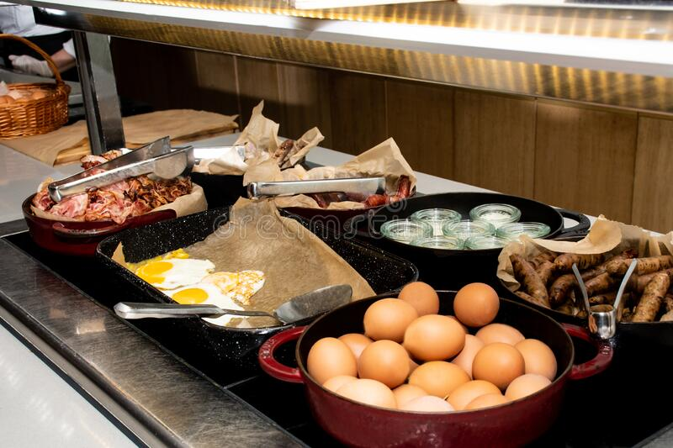
Hot breakfast should include an egg dish, simply prepared such as fried, scrambled, or boiled, or they could be included in a breakfast burrito, frittata, or eggs benedict. Meat should also be provided, generally bacon, back bacon, or sausage, either on its own or as part of the egg dish. The chef will also prepare starch, such as hash browns or sweet potato. This component could also be something sweet such as pancakes, French toast, or waffles.
On days when the Chef does not prepare sweets, the Pastry chef is to provide a fresh baked goods such as a strudel, sweet bread, pain au chocolate, mini muffin, or croissant.
As breakfast can be a very different meal in other parts of the world, some lodges may choose to add items to the breakfast buffet to accommodate our international clients for example miso, rice and raw egg or fish for Japanese guests or a cured meat and cheese board for Europeans.

Exchange Day Lunch Buffet
Every lodge has different times when their guests leave and arrive on exchange day. For a lodge with an early exchange, guests will have breakfast before departing. Incoming guests will arrive to a lunch buffet. Other areas will have a buffet lunch for outgoing guests and incoming guests will be provided with a snack, generally a charcuterie selection and of course a full cookie jar.
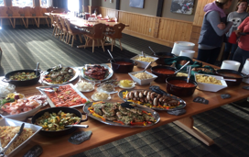
Exchange day lunch will be served buffet style in the dining room. When doing a buffet chafing dish must be used. It is the responsibility of the culinary team to ensure it is set up properly and the food presented and garnished attractively. The exchange day lunch buffet will set the culinary tone for the incoming guests or be their last impression from their trip for outgoing guests.
Each member of the culinary team will have specific items to prepare. The buffet should consist of both hot and cold items. One to two salads should be prepared, for example, mixed, Greek, potato, quinoa, pasta, or Caesar. Other cold items could include a smoked salmon or cold shrimp plate, devilled eggs, dips, breads, and charcuterie. There should be at least 3 Hot items which could include but are not limited to pasta, shepherd’s pie, burgers, stir fry, curry, casserole, and homemade soup. At least 1 vegetarian option should be offered. During the week, the culinary team may choose to make extra of some items that can be used on the buffet. Exchange day buffet is a great way to clean the fridges and reset them before the food order and next guests arrive but ensure it does not look like a table full of leftovers.
A variety of bite-sized desserts will be provided by the pastry chef, these can be smaller versions of the previously served nightly desserts, but some new options should also be provided.

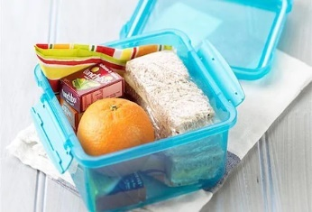
Field Lunch
The First Cook is responsible for planning and preparing the field lunch. Sandwiches and extras (such as crudité, fruit, baked goods (provided by the Pastry Chef),, granola bars, canned seafood etc.) will be wrapped and placed in lunch boxes. These containers will be sent out in the field along with cold beverages, Heli-snacks (provided by the Pastry Chef), soup and hot tea (provided by the Chef or Sous chef).

Lodge Lunch
The First Cook is responsible for preparing a hot lunch for staff and guests that are in the lodge. The expectations of the First Cook are to use a combination of leftovers and new products to create lunch items both nutritious and delicious. A variety of items should be served that will accommodate the various dietary requirements of all the staff and guests. In addition to hot items (i.e.. stir-fry, pizza, soup, casserole, hot sandwiches) they should provide at least 1 vegetarian item and a salad (green, pasta, quinoa, wild rice) as well as possibly leftover desserts.

Lunch In
Due to weather conditions, the ski program may be delayed or cancelled, which will mean that the guests will not be out in the field for lunch. Sometimes the program is delayed in the morning, and they may have lunch in and then head out to the field. If they are out in the field when the program is cancelled, the First Cook may have as little as a half an hour's notice from the lead guide that everybody will be returning.
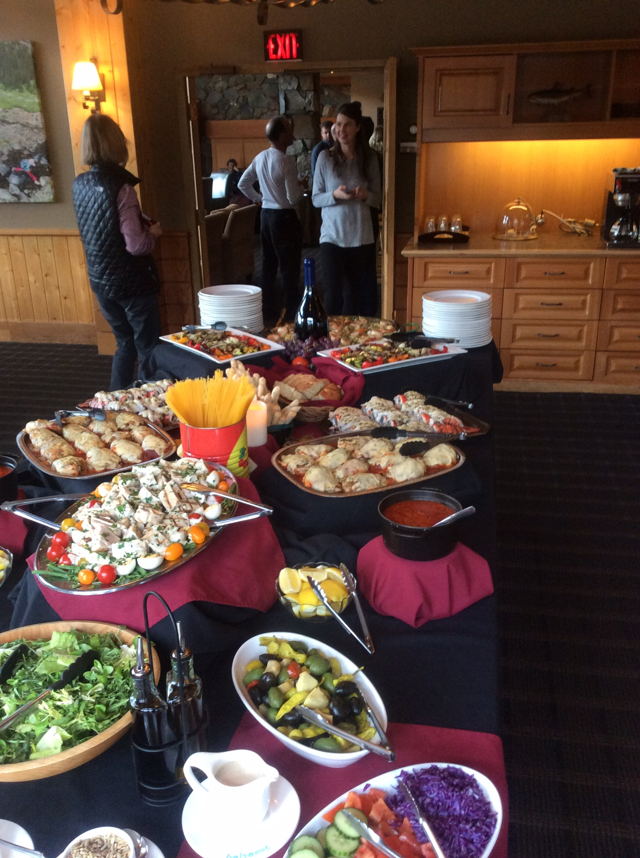
There are several different ‘levels’ of Lunch in. Generally, the first one will be a simple presentation of the field lunch in the dining room. After that, there is an expectation that each additional Lunch In will have additional options and more selection - becoming like exchange day buffet. As the lunches become more elaborate, the First Cook will require more support – hot items from the Chef and Sous Chef and desserts and bread from the Pastry Chef.
- First Lunch In – Sandwiches and soup served in the dining room.
- Second Lunch In – Sandwiches plus hot dish, salads
- Third Lunch In – Similar to exchange day buffet – Hot dishes, salads, bread, desserts

This is a general guideline of how to elevate Lunch In throughout the week. There are many considerations when balancing the ski and hospitality programs. The expectation is that we need to step up the lunch experience when guests are unable to ski.

Après
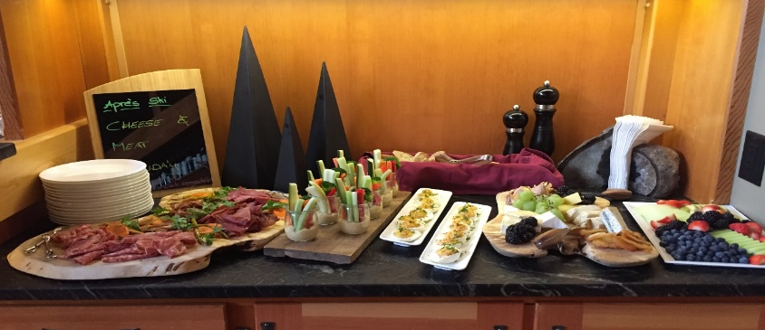
Each afternoon when the guests arrive back at the lodge, we provide a “Après Ski” snack for them. The Sous Chef will generally be responsible for Après but other members of the culinary may participate as well. Always serve a choice of at least two or three items with one of them being vegetarian/vegan as well as items for guests with special food requests. Like every other meal standard at CMH, Après must provide variety and quality. Common offerings for Après include nachos, chili, chicken wings, pizza, quiche, tacos, pulled pork sliders, ribs, samosas, smoked meat, dips and breads, charcuterie, and sausages. Ensure there is plenty of variety and provide all the necessary accompaniments and condiments. Addition of a daily smoothie and a fruit/veggie plate or salad will provide nutritional balance. Après may be served as a buffet or plated.

Dinner
Dinner will consist of fresh bread, appetizers, main course, and dessert. Good communication with the lodge and area management is necessary as each lodge has different requirements regarding meals and service. Main course should vary each day regarding preparation and nutritional values. Heavy meals and lighter meals should be interchanged during the week to make the guests’ dining experience more enjoyable and interesting. Dietary needs are a big part of the meal program in the lodges and must take top priority and be always adhered to. Using the special food requests report, the Chef, Pastry Chef and Sous Chef will plan and prepare the necessary alternatives to the regular dinner menu to ensure all guest special requests are met.

Dinner Service Meeting
Each dinner you will go over the meal you have prepared with the front of the house. Work with your Lodge Manager to pick a daily time that your servers will come into the kitchen to learn what is for dinner. You will cover if you have prepared a plated meal, family style or a buffet. Your servers will need to know what has been prepared and how you would like them to facilitate dinner service. This a great time to go over the allergy list and explain what special meals you have prepared.

Dinner Service
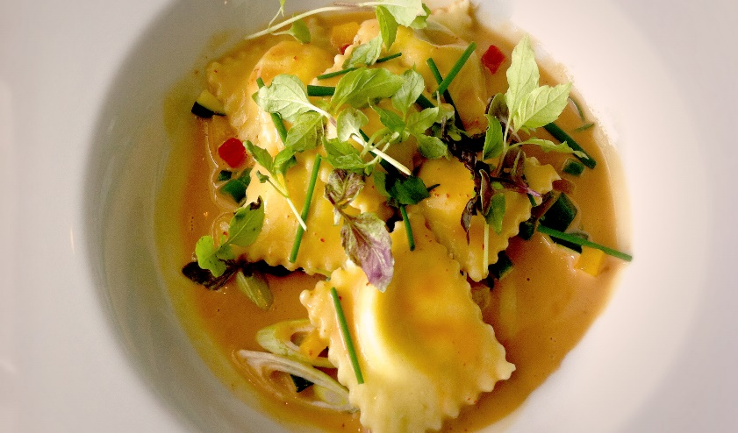
The dinner expeditor is a staff member who co-ordinates dinner service and manages communication between the kitchen and dining room. Along with the Chef and Sous Chef, they will complete the expeditor dinner sheet detailing all special meals for guests and staff to organize and facilitate service and ensure that all meals are delivered to the proper guests and staff in an organized, seamless manner.

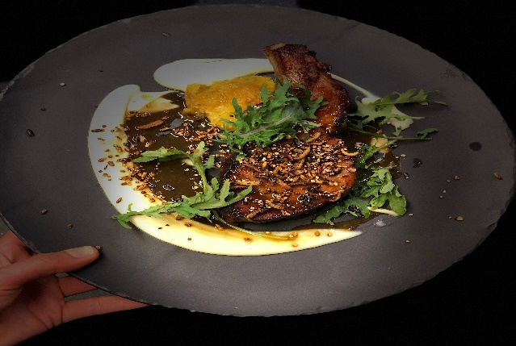
At dinner time, fresh bread will be delivered to the table and appetizer will be served to the guests once seated. Soup may be plated in the kitchen or at the table. A salad bar or plated salad may be offered between the appetizer and main course.

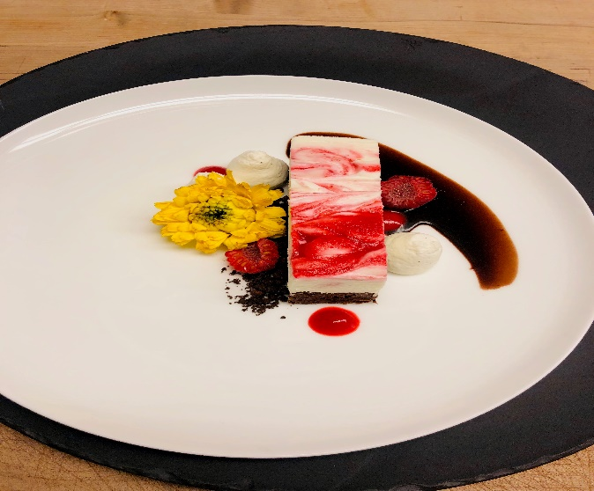
The daily dessert creation will be served to the guests by front of house staff once they have all completed the main course.


A cheeseboard, or individual cheese plates will be available after dessert usually at the bar.
Please refer to SOPs for Dinner service, cheeseboards etc. for further details

COMMUNICATION AND TEAMWORK

Culinary Team
Working with the rest of your culinary team to plan the weekly & daily menu is integral. For most of the meals there will be contributions from several individuals and good communication will ensure the best possible result. When communicating with your team you must always strive to be professional, kind, clear and to employ active listening. It is strongly suggested that weekly culinary team meetings are held and recorded to discuss menus, any arising problems, equipment needs ect ect. and to follow up on any concerns with the lodge managers and culinary manger.

Lodge Staff
You may have lodge staff to help prep food and complete cleaning tasks. Keep in mind that the people coming to do prep for you are not culinary professionals. You must demonstrate what you want and tell them how much you want, and where to put it when it is done. A daily food prep list should be created with tasks ranked in order of importance and specific instructions if you are not going to be in the kitchen to supervise or advise.
Lodge staff will be involved in dinner service. If they are helping to plate an appetizer, main course or are delivering meals, you must provide them with clear and polite directions when necessary.

Bartenders
The Bartender will post the evenings dinner menu along with suggested wine pairings for the guests. They will need your full detailed menu by 11am.
It is also very important for them to communicate with the kitchen regarding weekly orders as some bar items are on the iPad order spread sheets. Later in the season when they are increasing beer and wine orders, they should co-ordinate with the kitchen so that order weights are not going the exceed the maximum helicopter payload allowances.
The Bartender and/or House Assistant (2nd bartender) will also be involved in setting up for and replenishing Après, Exchange Day Buffet and possibly Lunch In. Please clearly and politely communicate with them as to your expectations and needs for these meals. The Bartender is there to help serve the Après not to execute it.

Staff & Guest food preferences
We consider all food preferences at CMH to be of the upmost importance. It is the goal to accommodate all preferences to the best of our ability. To help with this process our guest relations department has improved our dietary requirement sheets to include Allergies, Dietary needs and preferences. Also, you will have staff with dietary requirements, you will be given a list at the Set Up of everyone’s needs.
Sometimes you will receive requests at the last minute, so make sure you are prepared with some alternatives that can be pulled at a moment’s notice.

Lodge and Guides teams
There will be many people helping with the delivery of the culinary program. The more you work together the easier and more enjoyable it will be. CMH is a “all hands-on deck” kind of company. Be sure to take the time to explain how and why you need something done. And be open to suggestions, a good idea can come from anyone and at any time.

Ski program
Depending on the ski program all culinary timelines can be affected.
- Down days – means no skiing for Safety and or Weather restrictions.
This means all the guests will be in the lodge for the entire day.
- Guests coming in early from skiing will join the Lodge Lunch – this happens daily. Be prepared to have more than just staff in for lunch.
- Lunch In – everyone is coming in for lunch.
- Ending the day of skiing early – this might mean the Tea Goodie needs to come out early.
- Skiing later than anticipated – usually in the spring, but they could be stuck out in the field due to weather, and this can affect après and dinner times.

Appendix A : Health Inspections
Health inspections will be conducted at lodge every year. You will find a full tutorial and all the necessary forms you will need to be fully prepared for a health inspection on the kitchen tablet in each lodge. A full list of all the paperwork you may be asked for can also be found in the culinary team on “teams”

Food Safety Plan Components
1. Potentially Hazardous Foods
Describe the procedures to follow when handling any potentially hazardous foods that are served in your establishment. Potentially hazardous foods are those that can support the growth of disease-causing microorganisms or the production of toxins. Usually these foods that are considered perishable. Examples:
- Foods of animal origin (meat, fish, dairy, eggs, etc.)
- Foods of plant origin (vegetables, fruits, etc.) that have been cut or cooked.
- Raw seed sprouts (alfalfa, bean sprouts, radish sprouts, etc.)
- Cooked starches (pasta, rice, etc.)
- Soybean proteins (soy milk, tofu, etc.)
2. Critical Control Points
For each potentially hazardous menu item, create a food safety plan using a step-by-step procedure that identifies the critical control points.
Critical Control Points (Critical Steps): A Critical Control Point (CCP) is a step in the preparation process where a food safety hazard can be controlled. Subsequent steps in the preparation process will not eliminate the hazard if it is not controlled at this point. Some items will have more than one CPP. Clearly identify these steps for each potentially hazardous food item. Examples of CCPs are: receiving, storing, preparation, cooling, cooking, reheating and hot holding.
Not all steps are always considered critical. Some may be considered critical steps for some menu items, but not other menu items. It depends on how the item is prepared.
3. Critical Limits
Critical Limit (Food Safety Standard): A Critical Limit is a measurable standard or limit that must be met to control the food safety hazard at a Critical Control Point. Examples:
- cold storage temperature of 4°C or less
- final cook temperature of 74°C
- hot holding temperature of 60°C or more
- cooling food from 60ºC to 20°C in 2 hours and 20°C to 4°C in 4 hours
4. Monitoring the Steps
Describe how you will ensure that the critical limits are adhered to. Monitoring can include measuring an internal temperature, visually assessing food, or observing practices.

CMH requirements
- Reference binder
- Fridge/freezer temperature monitoring sheets (posted beside every cooler and filled in twice a day)
- Certifications
- Kitchen/spa/water/sewage (should be in the binder too)

Appendix B : Logistics of the CMH Culinary program

Food transportation and Receiving
CMH uses 3 different vehicles for food transportation.
- Kenworth supplies RE, MO, GO, AD, GL and KO
- 5500 Ram or the Ford 600 supply BB, PH and BU
- The Sprinter supplies our northern Valemount and Cariboo areas.
All trucks are refrigerated and are loaded and dispersed from Jay Street

Receiving food and supplies
Your food truck will come to the lodge on a weekly basis. On this shipment there will be anything from skis, first aid supplies, food, and alcohol.
Dry Food and Supplies
Dry food will be received and placed in the appropriate storage area. Your lodge may require you to date items throughout the season. When restocking shelves, ensure proper rotation.
Supplies such as linens, glasses, hospitality items or shop items are to be taken to the appropriate location in the lodge. The packing slip or orange sticker will be attached to the box to indicate where to take the item.
Bar items are to be placed in a pre-determined area for the bartender to count against their invoice and then they will arrange the items to be taken to the liquor cage or wine cellar.
Equipment such as batteries and motors are ordered by the Procurement Manager or Hospitality Purchasing coordinator. Confirm with your managers or maintenance person where to place these items so they do not get misplaced.
Fresh Food
All fresh food has been kept in the refrigerator or inside a reefer-cooled truck if it is being left for a period. Most of the fresh food will arrive on the same day it is being loaded onto the truck, so the pallets can be built and loaded directly onto the truck.
Once your fresh items arrive at the lodge you and your team will quickly offload the truck or helicopter to get them into the appropriate location. Be aware that sometimes item can be packed in unmatched boxes, meaning CHECK, any box that looks like it has been opened, it could have something unexpected inside.
Frozen food
Similar care must be taken to ensure all frozen food maintains a correct temperature. Frozen food is always kept in the warehouse freezer or in the front freezer compartment of the Kenworth. Frozen food traveling in the Ram 5500 or Sprinter will be left in the freezer until the last possible moment, as neither of those vehicles have a frozen compartment to keep it in.
Again, you and your team will unload the truck or helicopter and quickly put the frozen items away.

Truck schedule
Will be provided by our logistics manager in the fall and updated as requirements and needs change during the year. This Calendar can be found in the culinary section of “teams” as well as the kitchen tablet.
Day: | Receiving: | Shipping:
Sunday
Monday
Tuesday | Fresh food BB, BU, PH  Specialty BB, BU, PH, CA, VA  Frozen BB, BU, PH
Wednesday |  | Ram 5500 to Golden airport for BB, BU and PH  Sprinter to CA, VA With specialties.  Gfs to CA, VA
Thursday | Fresh food AD GL MO GO, KO  Specialty AD GL MO GO, RE, KO Freezer AD, GL, MO, GO, RE, KO
Friday |  | Kenworth to RE MO GO AD KO GL
Saturday

Heli – need to know list
Helicopter max payload
212 - 3000 Lbs.
206 - 800 lbs.
407 - 1400 lbs.

Suppliers
We have specifically chosen suppliers over the years for many reasons. With 55 years of history, we have an incredible relationship with most of our suppliers.
- Quality: For example, fish supplier flies his product in fresh every day, some of our other suppliers spend a lot of time and money sourcing local and organic products
- Service: CMH has very specific and unique needs including timing, logistic issues, and freshness of product, so it is important that our suppliers can accommodate those needs
- Accessibility: To meet all our guests’ dietary needs this usually means that very specific specialty items are needed. Some of our suppliers have been chosen because they are able to provide those items with very little notice.

