

Pastry Chef Reference Manual S27

Welcome to CMH! Due to the uniqueness of our vast operation, please consider this manual your training guide to service standards, expectations, and job descriptions.
The fact that you have been chosen to join this distinct group of adventure tourism professionals means that you play an integral role in the creation of one of the finest backcountry experiences in the world. It is our goal to ensure that CMH is known not only for its Heli-skiing and Heli-hiking but also for its hospitality program, which you are now a part of.
We are expecting you to bring your personality, creativity, knowledge, and professionalism with you to work every day to ensure that every guest has an exceptional experience.
It is important to us at CMH that you are given the tools and support you need to succeed in this business. We are not only committed to creating memories for our external guests, but for you, our internal guests as well.
We want our team to feel motivated, inspired, and healthy so that we can maintain a level of excellence that is unparalleled in our industry. If at any time you feel as though you are lacking information or skills that you need to better your performance, please take the time to communicate and we will do our best to fulfill your request.
We are excited to have you join the CMH family, a company that is devoted to creating unforgettable experiences for every single guest, every single time.

Your team:
Randy Luft - CMH Culinary Manager rluft@cmhheli.com
Sarah Palmer Culinary Purchasing Manager SPalmer@cmhheli.com
Alan Fraser – Director of Hospitality afraser@cmhheli.com

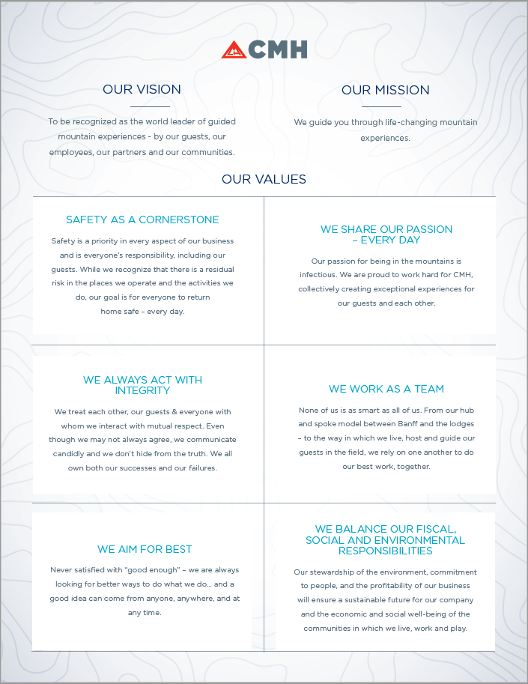
Contents
PASTRY CHEF BASIC DAILY TIMELINE 4
EXCHANGE DAY 5
HANDOFF 5
BREAKFAST STANDARDS 5
COOKIES AND HELI SNACKS 6
BREADS 6
DESSERTS 6
MENU PLANNING 8
DIETARY NEEDS 8
DEALING WITH LAST MINUTE GUEST REQUESTS 8
TIPS AND TRICKS 9

PASTRY CHEF BASIC DAILY TIMELINE
Time | Duty
6:00am  (or earlier) | Keener Start! Start working on your dinner bread Especially if you think you are going skiing
6:30 | Fruit Salad
 | Muesli (if your lodge provides this for breakfast)
 | Granola
 | Smoothie (if your lodge provides this for breakfast)
 | Chia seed pudding or other vegan/GF offering
 | Baked good unless chef is doing pancakes/French toast/waffles
7:45 | All above items should be bowled or trayed and ready to go out for service
 | Heli snack packaged
8:00 | Breakfast Service, help chef if needed if not start daily prep
8:30 | Staff breakfast
9:30 | Heli Snack
 | Dinner bread
 | Dessert Prep
11:00 | Dinner menu for bartender
 | Add items to prep list
12:30 | Lodge lunch (Staff & Guests that have come in early from the field). If there is a Lunch In (All Guests and Staff) you may need to have some dessert items and bread ready
1:00 | Break
5:30 | Return to kitchen
6:45 | Dinner bread in oven. Pre-Dinner Meeting
6:50 | Dinner bread ready for tables
7:30 | Cheese board ready for after dinner
8:00 | Desserts plated and ready to go
 | Bake off cookies for field lunches if needed

EXCHANGE DAY
Whether you are leaving, arriving, or bridging tours today is an exceptionally hectic day. While every lodge has different exchange times, there will still be breakfast, lunch and dinner and the incoming and outgoing staff must work together to ensure that all meals go smoothly. Breakfast on exchange day will be business as usual but may be 15 minutes earlier. Lunch is usually served as a buffet, either to outgoing or incoming guests depending on the guest exchange time. Dinner items will be prepped and planned by the outgoing pastry chef and prepared by the incoming pastry chef. As always, good communication is key. You will often have some time to speak personally with your cross shift, but not always.
LUNCH: A buffet lunch is served on exchange day, either for incoming or outgoing guests. You will be required to provide a selection of dessert and possibly bread for the buffet. The dessert tray should consist of at least 3 different kinds of desserts. Please make sure everything is displayed attractively.

HANDOFF
If you are leaving, you must have the incoming Pastry Chef with that evening’s desert prepped and ready. Please ensure your station and fridge area are clean and organized. Leave the other Pastry Chef a detailed note if you are leaving food (sauces etc) for them to use, especially if they contain allergens. As well, leave details about any food you would like included in the next order.

BREAKFAST STANDARDS

Fruit Salad: Pineapple, cantaloupe and honeydew can be prepped in advance. Kiwi, strawberries can be added in the morning. Frozen fruit may be used if there is a shortage of fresh. Berries to garnish.
Bircher muesli: Oats must be prepared in advance, add fresh grated apple and nuts (depending on recipe) in the morning.
Granola: You are responsible for making large batches of granola which the Lodge Staff to put on the buffet daily.
Baked Good: A breakfast pastry or baked goods such as banana bread, mini muffins, strudel, pain au chocolat or cinnamon buns should be served every morning that the chef is not making pancakes or French toast. Croissants may be served every day.
Chia Seed Pudding This can be prepared before hand and should last in the fridge for about 3 days and can be a variety of flavors. Try and have them vegan as this is a easy go to breakfast item for our guests.

:

COOKIES AND HELI SNACKS
Cookies: Cookies for field lunches should be baked off the day before. Ensure there is enough for all guests, pilots, guides as well as some for the cookie jar. A square and or cookie should be provided every day, and there should be a selection in the jars. Don’t forget a gluten free option for those with special requirements.
Heli Snack: Can be squares, energy balls house made granola bars ect. ect. To ensure we provide our guests with sustainable fuel, heli snacks made with emphasis on nutrient/protein dense ingredients such as nuts, superfoods and dried fruits is preferable over a sugar laden treat. Gluten and dairy free options must be available.

BREADS
Different dinner bread is produced daily. Talk with the Chef about the menu plan and choose an appropriate bread to go with the meal. In general, prepare one loaf per 10 people with 2 or 3 extra for back up, whenever possible try and make sure there is a few loafs extra so we have the option to use it for the toast station in the morning and as a different sandwich bread for the lunch program. You will be expected to slice and present (either in a basket or bread board) warm bread for each table. It should be ready to go out to the tables shortly before appetizer is served. Extra loaves can be placed on a cutting board with knife for serving staff to access should they require more. Ensure you have a gluten free option available.

DESSERTS
You are responsible for making the last impression of the culinary experience each day. This is your opportunity to use your talents as a Pastry Chef to showcase everyone’s favorite course. Dessert should pair well with the rest of the meal, be delicious and attractive. While a dessert may be simple, it should be visually impactful through your choice of plate, presentation, and garnish. Be creative with color, combine textures and provide a focal point as you compose your dessert. To encourage all guests to enjoy your dessert, smaller portions are recommended. A variety of options for guests with special dietary needs must be provided and can be made in advance and frozen for when it is needed. Having a few recipes that cover all the food sensitivity bases is also a great option.

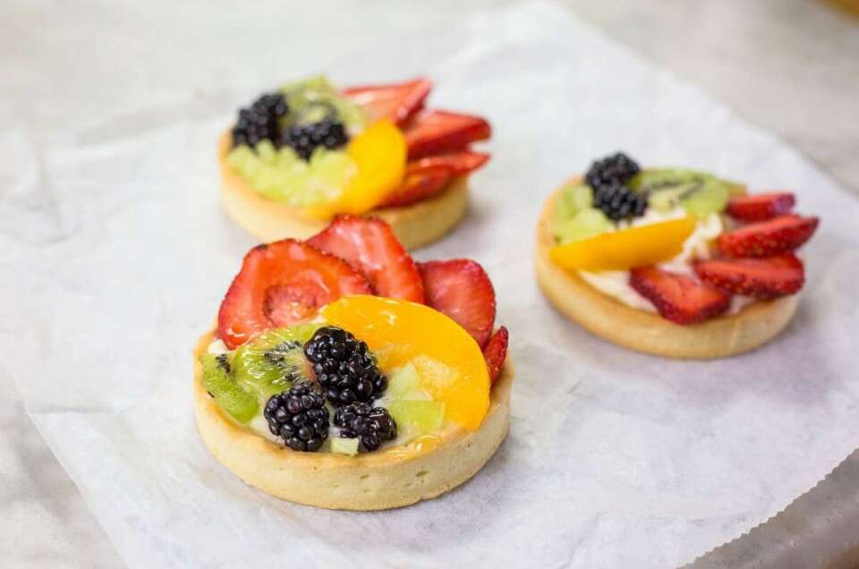

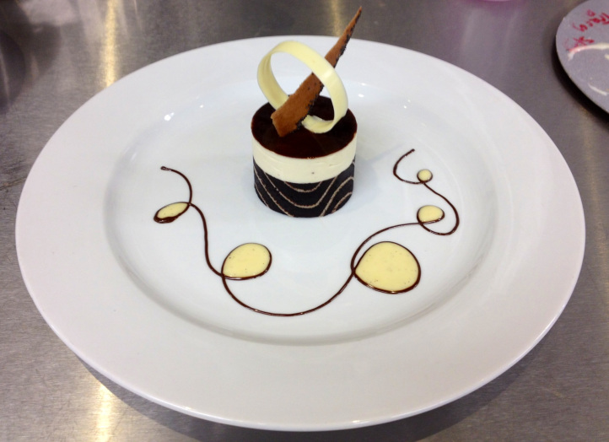
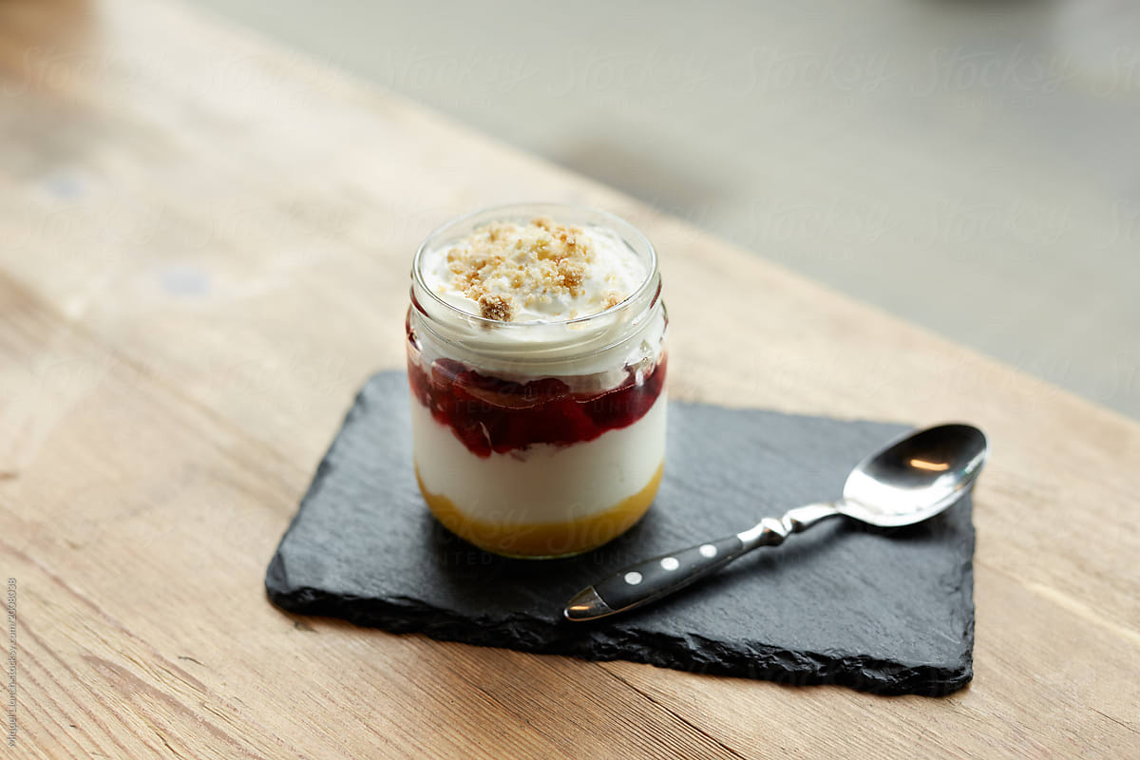

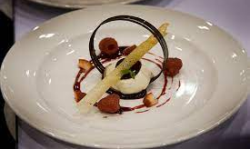
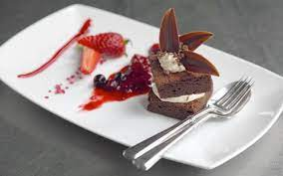
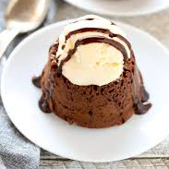
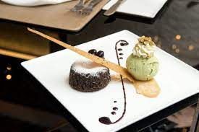
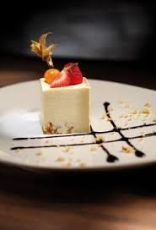
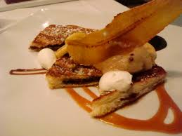
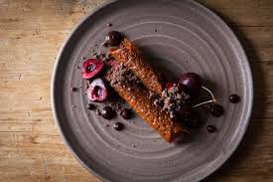

MENU PLANNING
The weekly menu will be created with input from all members of the culinary team. Please see the CMH Culinary Manual for details on the process and standards.

DIETARY NEEDS
You will have the master copy in the IPad as well as a report for each tour from your Lodge Manager. Some guests are vegetarian, and some have religious beliefs or have food preference & allergies. You should accommodate these requests to the best of your ability. Make sure you talk to the guest "in person" and find out exactly his/her dietary needs are.
Make a general announcement at dinner on the first night, inviting guests to let the kitchen know if they have any specific food requirements.
Please forward any special food requests that are not on the printed list to the Lodge Manager so that they can update the guest profile before they leave the lodge.

DEALING WITH LAST MINUTE GUEST REQUESTS
Sometimes you will have little notice that you will need to provide an alternate dessert. It may be a simple as a dish of ice cream, or you may need to get a bit more creative, especially if the guest has a food allergy. Ensure that you have some items on hand to ensure that all guest needs can be accommodated in a timely fashion.

TIPS AND TRICKS
Bulk rise bread dough overnight in fridge
For dinner bread, scale your loaves to 500g and have about 7 loaves for dinner.
Some of the fruit salad prep can be done in advance such as peeling and/or cubing of melon and pineapple.
Bake extra bread for the Lunch Chef. Focaccia and other flat breads can be particularly convenient for them.
On the first night of the tour prepare enough dessert for everyone. Then you can gauge how much for the rest of the week.
Have gluten free/dairy free/nut free options for heli snack and dessert. Find recipes that will freeze well so you will always have some on hand.
Meat and cheese boards can be made in advance if you wrap them tightly.
Make large batches of cookie dough. Scoop and freeze on trays then bag store them in stacked, labelled milk crates in the freezer.
Check GF bread supplies.
Check granola levels. Keep backup in freezer.
Toast nuts in large batches.
Tray up berries to prolong their life.
Leave your station clean.
Clean up fruit section, preparing it for exchange day for the new fruit, get rid of boxes, process fruit.
Clean shelf in fridge so it’s almost empty on exchange day.
If you are arriving on your first week, check notes, what was left for you, start organizing yourself for the week.
Check when your Beacon training is so you are organized to attend.
A few days of basic Bircher Muesli can be made at a time. Grated apple, other fruit and nuts can be added later. A similar program can be used for the chia seed pudding.

