

First Cook Reference Manual
S27

Welcome to CMH! Due to the uniqueness of our vast operation, please consider this manual your training guide to service standards, expectations, and job descriptions.
The fact that you have been chosen to join this distinct group of adventure tourism professionals means that you play an integral role in the creation of one of the finest backcountry experiences in the world. It is our goal to ensure that CMH is known not only for its Heli-skiing and Heli-hiking but also for its hospitality program, which you are now a part of.
We are expecting you to bring your personality, creativity, knowledge, and professionalism with you to work every day to ensure that every guest has an exceptional experience.
It is important to us at CMH that you are given the tools and support you need to succeed in this business. We are not only committed to creating memories for our external guests, but for you, our internal guests as well.
We want our team to feel motivated, inspired, and healthy so that we can maintain a level of excellence that is unparalleled in our industry. If at any time you feel as though you are lacking information or skills that you need to better your performance, please take the time to communicate and we will do our best to fulfill your request.
We are excited to have you join the CMH family, a company that is devoted to creating unforgettable experiences for every single guest, every single time.

Your team:
Randy Luft - CMH Culinary Manager rluft@cmhheli.com
Sarah Palmer – CMH Culinary Purchasing Manager SPalmer@cmhheli.com
Alan Fraser – V.P of Hospitality afraser@cmhheli.com

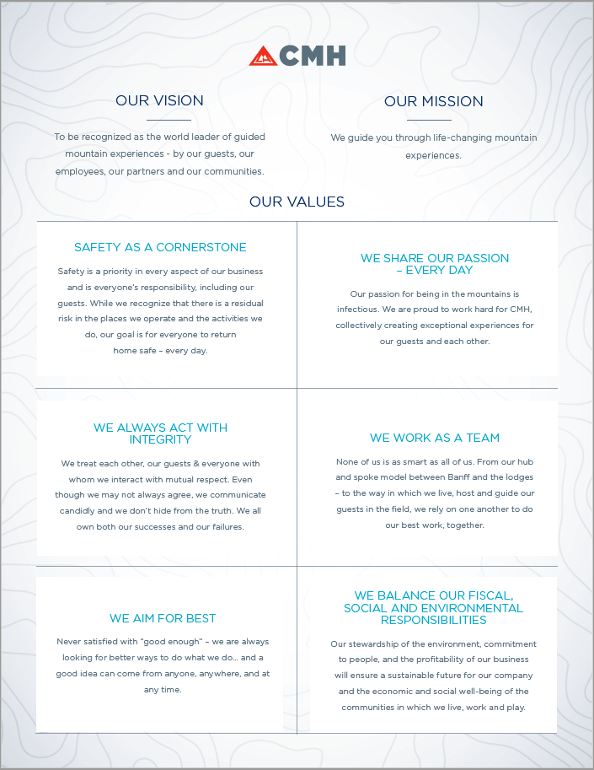
Contents
FIRST COOK BASIC DAILY TIMELINE 4
EXCHANGE DAY 5
FIRST COOK BASIC EXCHANGE DAY TIMELINE 5
LUNCH SIGN UP PROGRAM 6
FIELD LUNCH STANDARDS 6
PREPARING YOUR WEEKLY SANWICH PLAN 7
LODGE LUNCH STANDARDS 8
LUNCH IN 8
INVENTORY AND ORDERING 9
SANDWICH IDEAS 9
VEGETARIAN SANDWICH IDEAS 9
MEAT SANDWICH IDEAS 9
SEAFOOD SANDWICH IDEAS 10
TIPS AND TRICKS 11

FIRST COOK BASIC DAILY TIMELINE
 | Time | Duty
Field Lunches | 6:00/6:30 | Sandwiches – Make guests, pilots, guides, and some extras. Sous chef will be available to assist. Hospitality staff may help wrap, label and pack lunches
 | 7:45 | Guest lunches are packed and ready to go
 | 8:00 | Station cleanup & get organized for the day
 | 8:30 | Staff Breakfast
Breakfast Clean up | 9:00 | Breakfast dishes
Morning Routine | 9:45 | Sandwich prep (slice meats, cheese, cook proteins, wash lettuce)
 |  | Prep extras (veggie sticks, nuts, fruit)
 |  | Cleaning duties – Slicer, microwave, hood vents, dishwasher, walk in fridge on food truck day
 |  | Keep on top of the dishes throughout the morning
 |  | Clean and organize reach in fridge – think about Lodge Lunch
 |  | Organize your dry storage area. Check stock and if low put on order board.
 |  | Communicate with rest of culinary team about menu plan, orders, product usage, crossover
Lodge Lunch | 11:00 | Start Lodge Lunch
 | 12:30 | Lodge lunch - Staff & Guests that have come in early from the field – try to determine the time of return, number of guests. If there is a Lunch In (All Guests and Staff) you will have to be flexible
Break | 1:00
Dinner | 6:00 | Return to kitchen. Help chef with appetizer, if not needed start pots
 | 6:40 | Pre-Dinner meeting
 | 7:00 | Start Pots until chef is ready to plate dinner
 |  | Help Plate dinner
 |  | Eat dinner
 |  | Help chef put away food and finish pots
Final Prep | 8:30pm | Pull bread for sandwiches
 |  | Prepare for next day field lunches – Tally total sandwiches, print stickers, double check everything for the morning, any other prep that will make your morning easier (ie: prepack guide/pilot lunches, fill water/iced tea dispensers)

EXCHANGE DAY
Every lodge has different times that their guests leave and arrive on exchange day. For a lodge with an early exchange, guests will have breakfast before departing. Incoming guests will arrive to a lunch buffet. Other areas will have a buffet lunch for outgoing guests and incoming guests will be provided with a snack, generally a charcuterie selection and of course a full cookie jar. Each member of the culinary team will have specific items to prepare. You will learn your lodge specific program at set up. Inbound and outbound busses will be stocked with sandwiches, snacks and water for their journey. Outgoing staff should be provided with a selection of sandwiches and snacks to pack their own bag lunch for their commute.

FIRST COOK BASIC EXCHANGE DAY TIMELINE
The Day Before
Staff, self-drivers and guests taking special transport and their drivers will need bag lunches on exchange day. You should make these extra sandwiches the day before either while doing field lunches or in the afternoon. The night before you should pre-pack chocolate, fruit, granola etc. in bag, then add sandwiches in the morning. If there are a lot of early leaving guests, you can make a buffet for them to pack their own lunch.
 | Time | Duty
Early Lunches | 7:00 - 8:00 | Have all early lunches packed and ready to go by breakfast
 | 8:00 – 8:30 | Dishes
 | 8:30 - 9:00 | Staff Breakfast (if your lodge does staff breakfast on exchange day)
Breakfast Clean up | 9:00-9:45 | Breakfast dishes
Morning Routine | 9:45-11:30 | Make sure all prep is done for next day sandwiches
 |  | Salads for lunch buffet
 |  | Keep on top of the dishes throughout the morning
 |  | Clean and organize reach in fridge
 | 11:30 | Work on staff hot lunch and set up bag lunch buffet if needed  The staff may eat off the guest buffet in most lodges
 | 12:00 | Help with guest buffet
Staff Lunch | 12:30 | Staff lunch if needed
Handoff |  | If leaving, make sure everything is done, organized and clean for your cross shift, leave a detailed note
 |  | If staying or just arrived check notes, check prep, start organizing yourself for the week using sandwich sign up spreadsheet
 |  | Beacon practice
 | 3:00 | BREAK
 | 6:00 | See Basic Daily Timeline for rest of day

LUNCH PROGRAM
In all our lodges we have different variations of a lunch sign up program, whether it’s an online “QR” code system, an actual sign-up sheet or a combination. The guest will have the opportunity to have a say in what their lunch will contain. They will also have an opportunity to share any special requests, choose if they would like a different variation of what is offered or just want something simple like a PB&J. The lunch chef will be responsible for providing the weekly menu of sandwich choices in advance.
Keeping your guest menu simple will allow you to be creative and flexible during the week. Product availability and unforeseen circumstances may require you to make changes. The goal of the lunch program is to ensure guests get a lunch they will enjoy.
It is extremely important that you discuss what system your lodge is going to be using and what the specific standards are for your lodge.

FIELD LUNCH STANDARDS
Daily sandwich choice should include two meat and one veggie/vegan option. Protein options should rotate daily and should be prepared in unique ways throughout the week with additional consideration of what is being prepared for other meals that day. Other ways to provide variety throughout your menu include using different bread types (wraps, baker bread, ciabatta), different fillers (spinach, arugula, sprouts, cucumbers), prepared veggies (roasted, pickled, caramelized), flavored mayonnaise/aioli and of course a wide variety of cheeses. See below and Pinterest Recipes SOP for many more sandwich ideas. Communicate with chef if you would like them to cook off extra dinner meat for your sandwiches.
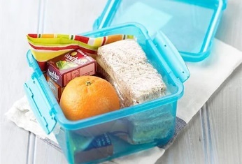
Sandwiches and extras will be wrapped and placed in lunch boxes. If your lodge uses a sandwich sign up the sandwiches will be labeled with Guest and guide names and placed in the designated lunch carrier for each group. In the morning you will need to get the group list from the guides so you can put the sandwiches in the proper lunch bin.
Some other items may be made available such as sardines, oysters, chocolate and granola bars. The 1st cook will also be responsible for providing cold drinks (water, lemonade or iced tea), cups, necessary cutlery, napkins, garbage bags, hand sanitizer/wipes and cream/sugar if guests request coffee. Lastly if your ski program ladles the soup for lunch, do not forget the ladle for the soup!!!
In addition to field lunches, the chef or sous chef will prepare soup and hot tea. It is the responsibility of the 1st cook to ensure that all Field Lunch components are ready to be picked up and brought to the heli by 8am.

PREPARING YOUR WEEKLY SANWICH PLAN
Below is an example of a basic weekly sandwich plan. As you will have already provided the menu to guests, you need to share your plan with the rest of the culinary team to avoid serving the same protein two meals in a row.
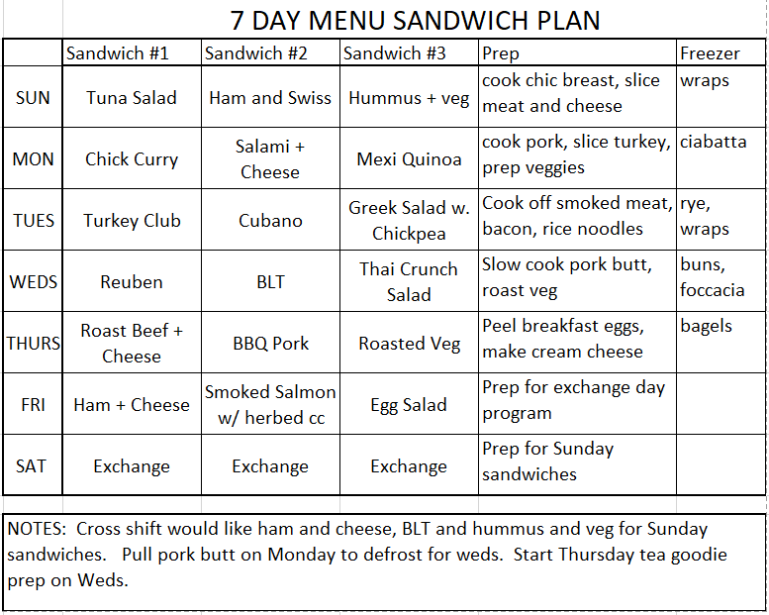

LODGE LUNCH STANDARDS
The 1st cook is responsible to make a hot lunch for staff and guests that are at the lodge. The expectation is to use up all leftovers and recreate them into something new and delicious for lunch. Nothing should just be reheated; this is your opportunity to be creative! Breakfast and dinner leftovers can be used to make pizza, stir fry’s, curries, noodle bowls, casserole, even added to pasta salad or hot sandwich filling. To ensure there is plenty of selection, you can also create dishes with new product. A variety of items should be served that will accommodate the various dietary requirements of all the staff and guests. In addition to hot items, you should provide at least one salad (green, pasta, quinoa, wild rice) and possibly other cold dishes (tapas, sushi, dips, and breads) as well as a possible selection of leftover desserts if the pastry chef has extra prepared. Always communicate with the rest of the culinary team to see if they have anything to contribute.
Lodge lunch starts at 12:30 for staff and any guests already in the lodge. Guests who choose to return to the lodge mid-day will usually have missed the field lunch and need to be fed upon arrival. This may occur sometime after staff lunch and there must be a fresh option available for them. If your break begins before all guests return, ensure that you have set something up for staff on duty to offer them.

LUNCH IN
Due to weather conditions, the ski program may be delayed or cancelled which will mean that the guests will not be out in the field for lunch. Sometimes the program is delayed in the morning, and they may have lunch in and then head out to the field. If they are out in the field when the program is cancelled, you may have as little as a half an hour's notice from the lead guide that everybody will be returning. Communication with the guiding team is essential!
There are several different ‘levels’ of Lunch in. Generally, the first one will be a simple presentation of the field lunch in the dining room. After that, there is an expectation that each additional Lunch In will have additional options and more selection - becoming similar an exchange day buffet. Remember chafing dishes must be used and sneeze guards are highly encouraged for all buffets.
- First Lunch In – Basic Lunch
- Hot soup
- Bring in bins from the field, unpack and nicely present in a buffet style.
- Second Lunch In – Sandwiches plus
- Hot dish
- Grill or bake sandwiches if appropriate.
- Simple salad
- Third Lunch In – Similar to exchange day buffet – No sandwiches
- 3 different hot items including at least one vegetarian option (Chef and Sous chef)
- A selection of salads
- Dessert selection (Pastry chef)
This is a general guideline of how to elevate Lunch In throughout the week. There are many considerations when balancing the ski and hospitality programs. The expectation is that we need to step up the lunch experience when guests can’t ski. Discuss a strategy with your management and culinary teams.

INVENTORY AND ORDERING
The 1st cook is responsible for the inventory and ordering of all lunch items including bread, granola/chocolate bars, cheese and meat and will provide their order to the chefs every week. The weekly order is sent to Banff. Please ask your chef when the order is to be sent in and when add-ons are possible.
Keep in mind that between ordering and delivery there is a significant delay, so do not wait until you are down to your last box of something to place an order. Supplier delays, special order items, ordering mistakes and product damage/spoilage will also affect product availability. Maintaining inventory and organizing your general menu plan weeks ahead of time in addition to clear communication with the culinary team is extremely important so that the products you would like are ordered and available. Remember that you will be ordering for your cross shift, and vice versa, so it is important that you communicate with each other about your expectations for on hand product.
As the season is winding down you will be expected to run down your stock to have minimal inventory at the end of the season, while ensuring that our last guests have the same experience as any other week. Communicate with your culinary team and Lodge Managers to order what is needed for the off season.

SANDWICH IDEAS
There is a SOP (Pinterest board) created with all different types of sandwich ideas as well as lunch ideas.

VEGETARIAN SANDWICH IDEAS
- Stir-fried veggies with tofu and cashews wrapped in different flavored tortilla shells.
- Roasted zucchini and peppers with asiago cheese and pesto mayonnaise.
- Sliced veggies with bean and cream cheese spread.
- Hummus with grated carrot, sliced cucumbers & peppers and other veggies on a pita or wrap.
- Falafel with tzatziki sauce in a pita.
- Smoked Gouda with roasted peppers and tapenade (olive spread) on Focaccia or Italian bread.
- Artichoke heart salad on a pita
- Roasted pepper cream cheese and veggies on a bagel.
- Roasted veggies tossed with dijonaise in a pita.
- Thai crunch salad wrap – julienned veggies, romaine, peanut sauce
- Mediterranean chickpea – cucumber, tomato, peppers, feta, chickpeas, balsamic dressing

MEAT SANDWICH IDEAS
- Roast beef with horseradish mayonnaise or red onion marmalade or sundried tomato & basil Dijon
- Sliced turkey with pancetta and herbed mayonnaise.
- Bratwurst and sauerkraut with Dijon in a baguette or torpedo roll.
- Ham and Swiss with honey mustard.
- Sliced chicken with mango chutney.
- Chicken Salad on Kaiser rolls.
- Curried chicken salad wrap
- Focaccia Heroes; salami, Jarlsberg, red onion and red peppers with garlic and oregano butter.
- Greek lamb salad pitas; small-diced lamb with Greek salad. Mix the night before then drain well in the morning.
- Egg salad with ham or bacon, onion and thyme.
- Oriental duck salad; diced duck, red onion, orange with Soya sauce mayonnaise in a wrap or a pita.
- Bunderfliech, Copa or another dried meat with sliced pickles, red onions, and Brie on a croissant.
- Pastrami and Swiss with sauerkraut, pickles, and Dijon. Reuban
- Mexican chicken/beef/pulled pork burrito, Mexican rice, sautéed onion, pepper, and cheese.
- Chicken with tapenade (olive spread), roasted peppers and pesto mayonnaise
- Prosciutto, Brie, and cantaloupe on a baguette.
- Roast beef with blue cheese mayonnaise or feta and goat cheese
- Roast pork with BB-Q sauce and coleslaw (well drained).
- Crabmeat and ham with horseradish mayonnaise.
- Slice turkey with cranberry cream cheese or cranberry mayonnaise.
- Turkey or chicken with bacon, lettuce, guacamole, and cheese
- Turkey or chicken with avocado sprouts and honey mustard.
- Turkey or chicken with grilled onions and BB-Q sauce
- Ham, sliced salami’s, Coupa, with roasted red peppers, gruyere, and red pepper mayo

SEAFOOD SANDWICH IDEAS
- Salmon salad, oriental or plain.
- Tuna salad, Asian style, spicy or plain.
- Baby shrimp salad; curried with veg and vermicelli or plain with boursin cheese on a pita.
- Smoked salmon with caper cream cheese and red onion slices on a bagel or in a wrap
- Smoked salmon with roasted red peppers, cilantro-coriander, and hot pepper mayonnaise

TIPS AND TRICKS
- Prepare all gluten free and allergy sandwiches first, to prevent cross-contamination.
- Lettuce wraps or bento boxes are excellent options for gluten free/low carb.
- Make sure that bread and filling are proportional. Thicker bread needs more filling.
- Make sure that bread and filling are complementary. It is okay to use the same filling on different types of bread in one day.
- Always use Size 2 for on the meat slicer when prepping meat boards and sandwiches. Thicker meat is hard to chew into during cold weather.
- Pre-separate smoked salmon leaves when making smoked salmon sandwiches.
- Save time by getting all your meat slicer prep done at the same time. Pay attention to order so there is no cross contamination or clean in between slicing meat and cheese.
- Tomatoes, cucumbers, and other water-based toppings (sauerkraut, pickles, etc.) get soggy and also freeze easily on cold days. Try resting slices on paper towel to absorb excess moisture or try roasting tomatoes in the oven.
- Tuna salad can get soggy. After preparing the tuna, let sit overnight in a fine strainer or cheese cloth to allow excess liquid to drain off.
- Spinach and arugula hold up to the cold better than some lettuces.
- If you have one complicated to assemble sandwich, the other should be simple (ie: a wrap with a pre-made filling) or you might run out of time.
- Communicate with chef about small amounts of leftovers that you may be able to use. For example, pesto can be added to mayo, spreads or dressings can be added to veggie mixes.
- Always make a few extra sandwiches of every kind just in case someone is extra hungry or there was a mix up and didn’t end up with what they ordered.
- Save time by pre-filling squeeze bottles of sauces. Ex: mayo, mustard, flavored mayo’s.
- Remember to double check any dietary quests on the incoming guest preferences sheet (separate from the sandwich ordering sheet). This ensures you have everything ready for the next person coming on shift.
- Keep an extra loaf of bread ready for any last-minute Peanut Butter and Jelly requests.
- Leftover breakfast sausage and bacon along with little amount of sandwich meat are good to use for pizzas, pastas, and soups.
- Leftover breakfast eggs can be used for egg salad, deviled eggs and for ramen noodle bowls.
- If you have a lot of gluten free/celiac staff or guests and making pasta for lunch in use gluten free pasta for everyone.
- Soups are a good way to use left over rice, lentils, white beans, and dinner vegetable. Modify recipe when adding since they will already be cooked.
- Ramen noodle bowls are a good way to use up multiple leftovers and by keeping items separate and using veg. bouillon when making broth, you can accommodate multiple dietary needs (gluten free, dairy free, vegan, does not eat pork or seafood). You can also make a BIG batch of broth and freeze some for another day.
- If you have a lot of vegetarians/vegans make one big dish and leave meat separate for people to add.
- Can always use a vegetarian salad idea (Pinterest board) and put into a wrap for a sandwich.

